**Weatheryy!**

A Weather Forecast Command-Line Tool

**Idea**

The Weather Forecast Command-Line Tool is a Python-based utility that allows users to obtain the current weather forecast for a specific city. Using the OpenWeatherMap API, the tool provides real-time weather information such as the description of the weather, temperature, maximum temperature, minimum temperature, and wind status. This document provides an overview of the tool's functionality, implementation details, and instructions for usage.

**What does the code do?**

The Weather Forecast Command-Line Tool:

· Accepts the name of a city as input.

· Fetches weather data from the OpenWeatherMap API.

· Displays the weather description, temperature, and humidity for the specified city.

**How does the code work?**

The tool is implemented in Python and relies on the requests library for making HTTP requests. It utilizes the OpenWeatherMap API to retrieve weather data in JSON format. The JSON response is then parsed to extract the required information, which is subsequently displayed to the user.

Instructions for Usage

To use the Weather Forecast Command-Line Tool, follow these steps:

1. Ensure that Python and the requests library are installed on your system.

2. Obtain an API key from OpenWeatherMap by signing up on their website.

3. Download the source code for the Weather Forecast Command-Line Tool from the designated repository on GitHub.

4. Open the command-line interface or terminal on your system.

5. Navigate to the directory where the tool's source code is saved.

6. Replace <YOUR_OPENWEATHERMAP_API_KEY> in the code with your actual API key obtained from OpenWeatherMap.

7. Execute the following command after copying the code, to run the tool:

**python weather.py**

8. The tool will prompt you to enter the name of the city for which you want to retrieve the weather forecast.

9. Type the city name and press Enter.

10. The tool will fetch the weather data from the API and display the weather description of the weather, temperature, max-min, and avg, wind speed, etc for the specified city.

**What will it look like?**

· If the city name is correct:

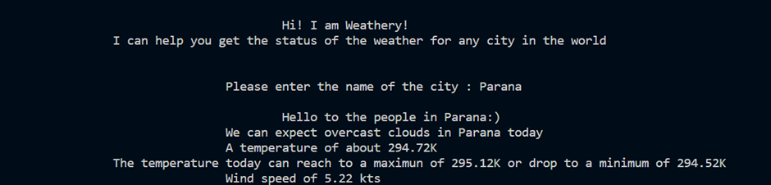

· If the city name is incorrect but the user wants to still enter the right name in the same session

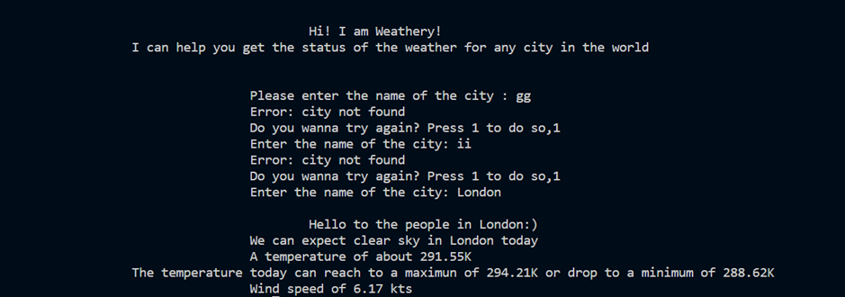

· If the city name is incorrect and the user does not want to continue:

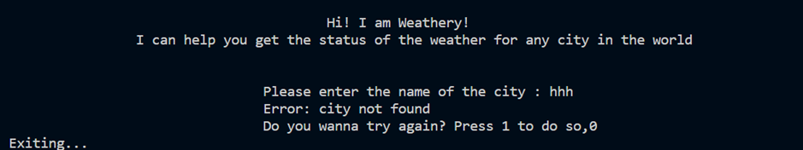

**Make sure**

· You ensure an active internet connection while running the tool to fetch weather data from the OpenWeatherMap API.

· Take care to provide the correct name of the city to obtain accurate weather information.

· In case of any errors during the retrieval of weather data, the tool will display an appropriate error message.

**Conclusion**

The Weather Forecast Command-Line Tool provides a simple and efficient way to access current weather information for a desired city. By leveraging the OpenWeatherMap API and Python, users can quickly obtain weather details such as description, temperature, and humidity. The tool's ease of use and functionality make it a valuable resource for weather enthusiasts and developers alike.